Mantid
Open Source Governance Model Proposal

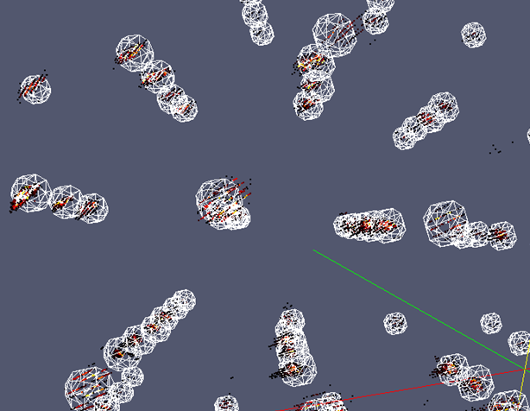
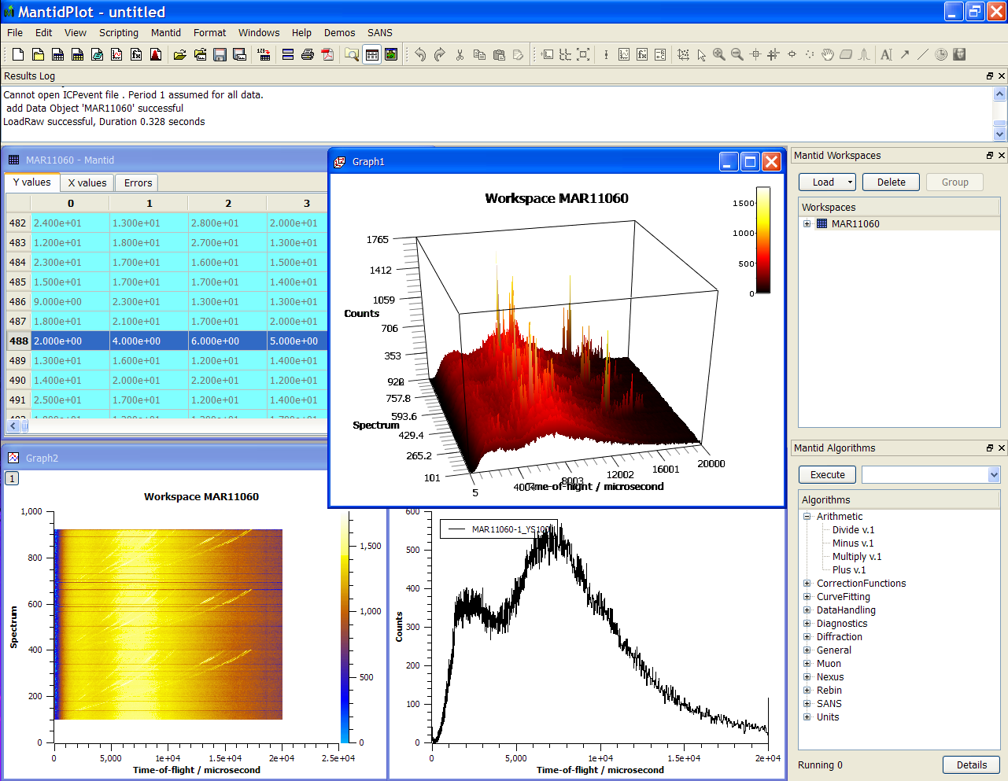

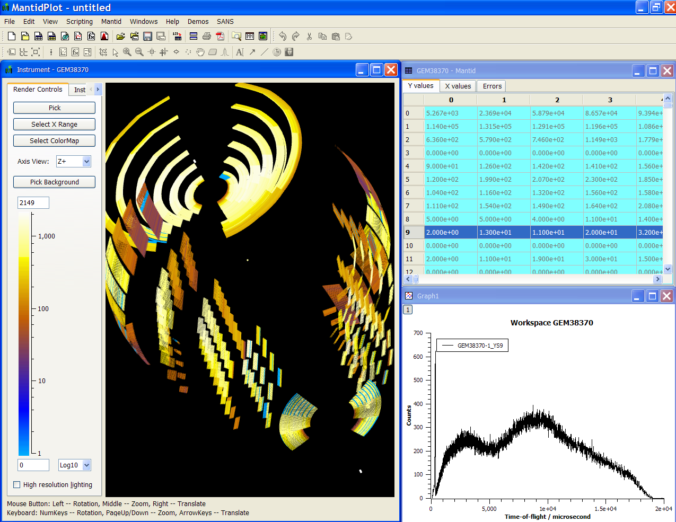
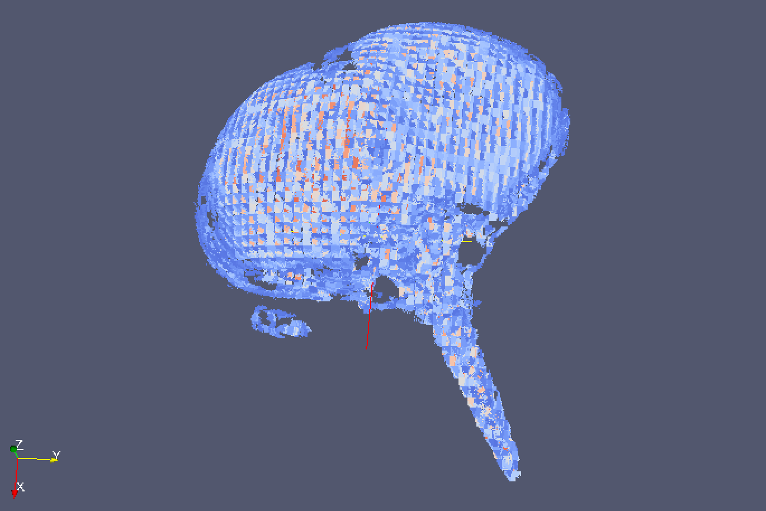
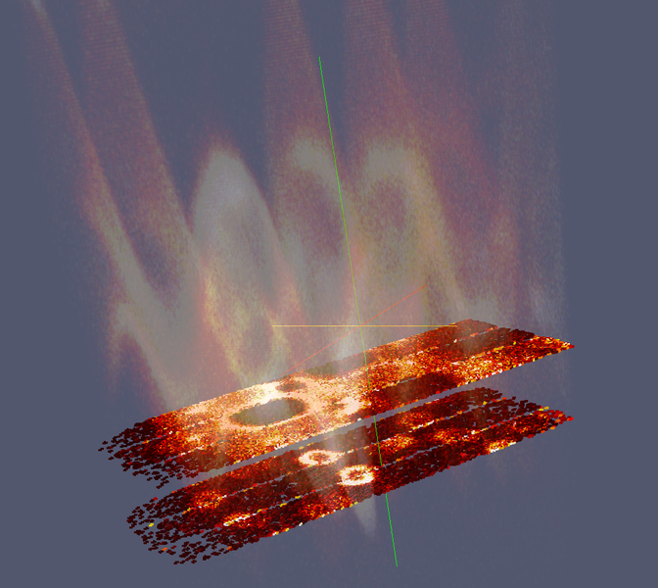
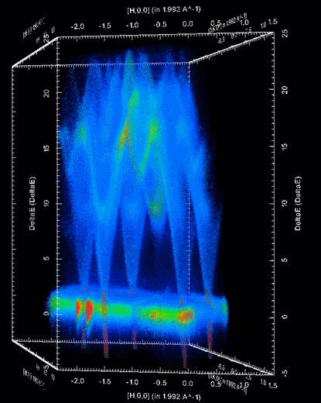
Document Control
This document is under document control. All members of the distribution list will receive updated copies whenever alterations are made. All other copies are uncontrolled.

Contributors
Name | Role | Company
Nicholas Draper | Author | Tessella

Document Approval
Name | Role | Company

Distribution
Name | Role | Company
Project Management Board Members | Recipient | STFC & ORNL
Mantid Project Repository | Filing | STFC & ORNL

Revision History
Author | Issue | Date | Description
Nicholas Draper | V1.R1.M0 | 19-Jun-2013 | 1st version written

References
Document | Ref | Date | Details and Version
Report on Open Source Governance Models | [OSGM] | 11-Jan-2013 | https://github.com/mantidproject/documents/blob/master/Project%20Management/PMB/Report%20on%20Open%20Source%20Governance%20Models.doc?raw=true
Memorandum of understanding between ISIS and NScD | [MOU] |  | http://github.com/mantidproject/documents/blob/master/Project%20Management/Collaborations/ORNL/Appendix%201%20to%20MOU-UTB-2006223%20-%20Rev2.docx?raw=true

Table of Contents
1 Introduction 3
1.1 Purpose of this Document 3
1.2 Scope of this Document 3
1.3 Context of this Issue 3
2 Current Mantid Governance Model 4
2.1 Scalability 4
3 Open Source Governance Models 5
3.1 Open Source Foundations 5
3.2 Company Owned Open Source developments 5
3.3 Benevolent Dictatorship 5
4 Suggested Governance Model for Mantid 6
4.1 The Mantid Collaboration 6

Introduction

Purpose of this Document
This document proposes a model for the future governance of open source collaborative software development between large scale scientific facilities. One project that would use this governance structure would be the Mantid project, but it would be available to support other projects as well.
The previous Mantid governance approach would struggle to expand beyond the two initial facilities, as detailed in the Report on open Source Governance Models [OSGM]. This proposed approach should be scalable both for Mantid, but also to host additional projects as well.

Scope of this Document
The scope of this document is to propose a governance structure for the future collaborative software projects including the Mantid project.

Context of this Issue
This is the first draft of this report for initial consideration by selected project management board members. It will be used as a basis for discussion at the next Mantid PMB meeting. After consideration at the PMB meeting it will be sent as a proposal to the facility directors of ISIS and the SNS for consideration. If approved this will form the basis of the governance structure for the collaborative software projects between the facilities involved.

Current Mantid Governance Model
Currently the Mantid project is managed as a collaboration between two international neutron science facilities, ISIS part of the Science and Technology Facilities Council, UK, and NScD part of the Oak Ridge National Laboratory, USA. The agreed governance of the project has been defined as an appendix to an existing Memorandum of understanding between the two facilities [MOU]. This defines the following points:
- Mantid should be developed as a single software package. Specifically, facility specific versions will not be released.
- Mantid will be developed and released under the GNU GPL open source license
- Copyright will be jointly held by both participating facilities
- The project management structure, specifically:
  - The Project Management Board, with annual rotation of the chairman position
  - Scientific Steering groups
  - Project Working group
  - Leadership of the project through a single project manager
  - Agreed standard for testing, documentation, and an agreement on maintenance of standards.
- Each participant should allocate a level of resources commensurate with their expected level of deployment and development.
- Each participant will plan to support their users locally.
- That the resources contributed may include third party staff at the discretion of the participant.
- A consistent method for citing the Mantid software should be used by all participants.
- Each participant agrees to treat information from other facilities as confidential.

Scalability
This model has served to the project well for the development of the project up to this point, but with other facilities expressing interest in joining this project going forward, the current model shows it weakness in the ability to scale beyond two partners. In particular the current arrangement of having agreements between each member of the collaboration means that with every change in the membership all of the agreements need to be updated. Therefore in the interested of stability in the face of future change this review looks at the governance arrangements of other open source projects.

Open Source Governance Models
An investigation of a collection of open source projects has found that most fall into one of three governance models:

Open Source Foundations
The open source foundations such as Eclipse, Apache and Linux operate using a single legal entity as a centre point for all collaborations. In each of these cases they are a not for profit organisation registered at an internationally recognised location. The foundation creates bylaws and membership agreements that all members must agree to abide to, and form the basis of the shared development of their desired software. Ownership of the copyright of the software remains with the foundation itself rather than individual members.
This approach allow for new members to join or leave the collaborative development without affecting the other members arrangements. However it revolves around a specific legal entity as the central body owning the intellectual property generated as a result of the collaborative development. The creation and support of this central legal entity requires significant time and resources as well as the legal requirements to create and file accounts etc. As a result of these overheads this approach is often used to support a collection of projects, as is done by both the eclipse and apache foundations. For example the Apache foundation supports a collection of 189, and the eclipse foundation 222 projects.
Foundations offer various levels of membership, giving access to internal mailing lists through to seats on the foundation’s board of directors. Access to these different levels of membership depends on the foundation, Apache offers higher levels of membership as a reward for contributions to its projects, while for Eclipse it is down to an organisations willingness to pay higher fees.
Smaller examples of this type of organisation do exist, but are still organised around large mass market projects, such as the Document Foundation which is the owner of LibreOffice, in this case the central legal body is a charitable organization based in Germany

Company Owned Open Source developments
MySQL is a good example of an open source project that is owned and developed by a single company, it is released as open source, but commercial support and customisation is sold alongside. MySQL was originally created and owned by MySQL AB, but has since been bought by Sun Microsystems and now Oracle.
In this case the governance and ownership stay within company itself, external development is encouraged, but restricted from the core of the product.

Benevolent Dictatorship
Many smaller projects fit into this structure where a single individual is responsible for the direction and management of an ad hoc pool of developers. In many cases the benevolent dictator is the founder of the project, and the team is comprised of friends and helpful developers met through the project itself.
This model is often characterised by having a lesser emphasis on governance, procedures or quality and often will not carry any copyright statement, or a statement referring only to the founder.

Suggested Governance Model for Mantid
Looking through the governance models found during the review it is apparent that at the moment the size of the Mantid project does not fit perfectly with any of the models found. It is too big for simple benevolent dictatorship, and that would not support the oversight that would be required by the collaborating facilities. Equally it is not big enough to create a foundation to form the collaboration around, at least the effort and support of maintaining a charity or not for profit organization would not be a good use of tax payer funding from any collaborator.

One possibility however would be to take the positive aspects of the foundation model, and accept the loss of the aspects of forming a separate legal entity to form its core.

The Mantid Collaboration
The Mantid collaboration would be a voluntary association made up of its members, for the development support and promotion of the Mantid project, and possibly other collaborative science based software in the future.

Membership agreement
Each member organisation would sign an membership agreement with the Mantid collaboration which would contain similar items as we currently have in our [MOU] between ISIS and NScD. Membership at this level would give seats at the Mantid PMB, which would also initially server as the management board for the Mantid Collaboration. As the collaboration itself is not a legal entity these agreements would not be legally enforceable, but would be held as a “Gentleman’s Agreement”. We would continue to have the membership agreements signed by a senior manager of the company or facility joining the collaboration to publically acknowledge the commitment of senior management to the project.
In reality this is a similar level of protection to what we currently have with our addendum to the MOU, especially as most terms in the MOU are phrased as “should” or “may” rather than “will” or “must”.

Copyright
As it is not formed around a legal entity the collaboration itself would not be able to hold copyright. As such I would suggest that we continue the current practice that all members of the collaboration jointly hold copyright. This will result in changes to the source code along with changes in the membership of the collaboration, but this is a fairly easy task to implement.

Scalability
As each membership agreement is with the collaboration rather than the other members directly than any additional members or changes in the membership will not directly affect the membership agreements of other members, and would only have the effect of changing the total number of representatives on the Management Board. This would appear to solve the current problem of direct agreements between collaborators, assuming of course this would be acceptable to both ISIS and NScD.

